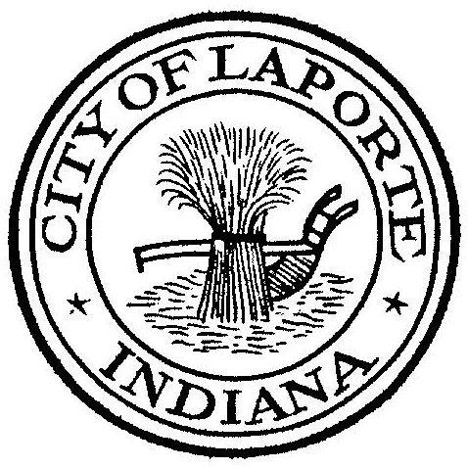
Board of Public Works and Safety
Jessica Romine, Member Tom Dermody, Mayor Mark Kosior, Member
City Hall 801 Michigan Ave., La Porte, IN 46350
Tuesday, April 16, 2024
9:00 AM
AGENDA
- Call To Order
- Pledge Of Allegiance
- Approval Of Minutes
- Public Comment: In Person and via Facebook Live
- Clerk-Treasurer: Claims Approval
-Credit Card Inventory Approval
-Vehicle Inventory Approval
- Department Head Reports
- New Business:
-Request for Use: NWITRI Triathlon
-Nick Otis: NIRPC Agreement w/Exhibits
-Dick Buell: Amended Client Service Agreement
-Beth West: Public Transportation Agency Safety Plan
-Jerry Jackson: New Wastewater Hauler Discharge Permit: Midwest Portables
- Unfinished Business:
- Other Business: Next regularly scheduled meeting: *Wednesday, May 8, 2024 at 9a
10) Adjourn

*Due to Primary Election Day on Tuesday, May 7th

